NON-CLINICAL PHOTOGRAPHY & RECORDING POLICY

Confidentiality Notice

This document and the information contained therein is the property of PCIG Consulting Ltd. This document contains information that is privileged, confidential or otherwise protected from disclosure. It must not be used by, or its contents reproduced or otherwise copied or disclosed without prior written consent from PCIG Consulting Ltd.

Document Control

Classification:
Policy Owner:
Permanent Delegation:
Document Reference: | 2.0
Date Approved: | 6th March 2024
Review Frequency:
Next Review Date:
Owners Signature:

Document Revision and Approval History

Version | Date | Created/ Revised by  (person(s)) | Approved by  (Committee) | Significant Changes
1.0 | 12/02/2024 | Paul Couldrey |  | Initial draft based upon clinet x policy with their consent
2.0 | 6 March 2024 | Paul Couldrey |  | Updated and reviewed

Introduction

Policy Statement

This policy details our rules on obtaining consent when taking non-clinical photographs or videos. In short, if the data subject has not given consent to use a photograph or video (which includes where and for how long it can be used), then it cannot be used.

Personal data relates to a living individual who can be identified from that data, including photograph and video. Taking and retaining photographs of people is considered personal data under the Data Protection Act 2018 and the UK General Data Protection Regulation 2016, meaning the data protection principles apply.

Consent must be obtained from anyone who appears in a photograph or video that [FED Name] will use. Consent must be obtained before the photography or video can be used. Explicit consent for pictures or videos of children and young people must be received. Any consent must meet the UKGDPR standards of being "freely given, specific and informed". A generic, all-encompassing form that states, "By signing below, you consent to us taking photos of you" is not compliant. Similarly, the consent will not be valid if the data subject feels pressured into giving consent. It must be a genuine choice, and the data subject must not suffer any
detriment if they decline to take part.

Photographs or video recordings that may be taken for use by [FED Name] must not be shared with any third-party organisations. If sharing is required, consent must be obtained from the data subject.

By gaining consent and observing our permission for photos and videos, [FED Name] can provide the necessary duty of care and privacy protection that remains in line with the broader organisational policies.

Status

[FED Name] aims to design and implement policies and procedures that meet the diverse needs of our service and workforce, ensuring that none are disadvantaged over others, per the Equality Act 2010. Consideration has been given to the impact this policy might have on the individual protected characteristics of those to whom it applies.

This document and any procedures contained within it are non-contractual and may be modified or withdrawn at any time. To avoid doubt, it does not form part of your employment contract.

Training and Support

[FED Name] will support all staff in understanding their rights and responsibilities regarding this information. Additional support will be provided to managers and supervisors to enable them to deal more effectively with matters arising from this guidance.

Scope

Who does it applies to

This policy applies to all employees, partners, and directors of [FED Name]. Other individuals performing functions about the organisation, such as agency workers, locums, and contractors, are also encouraged to use it.

Furthermore, it applies to clinicians who may or may not be employed by the organisation but are working under the Additional Roles Reimbursement Scheme (ARRS).

Why and how it applies to them

[FED Name] and all appropriate staff are to ensure compliance with this policy's requirements. Failure to comply with the policy and any associated patient data or confidentiality breaches could lead to prosecution or imposition of penalties by the Information Commissioners Office (ICO).

Taking Photographs or Recording Individuals
Before using their photographs for promotional or public relations purposes, prior consent must be obtained from employees (including locums, contractors, directors) and other data subjects.

Where images are required for identification badges, it is mandatory for employees to undertake this process, but the photograph will solely be used for security purposes only. Employees’ photographs cannot be used for any other purpose without explicit consent. A consent form is not required in this instance.

Retrospective consent after a photograph or recording has been used is unacceptable and a breach of UKGDPR. Consent must be obtained before any usage.

Internal use

The organisation’s photographs may be used for various legitimate purposes, including internal newsletters, company-wide announcements, directories, employee recognition programs, and other internal communications. Such usage is for official company purposes only; however, explicit consent must be obtained.

External use

External use of employee photographs, such as in marketing materials, press releases, or public-facing websites, will be done only with explicit consent from the employee. Consent forms will clearly outline the usage purpose and provide the option to grant or deny permission.

Taking Photographs or Recordings within a Private Environment
This includes in a staged consultation or within a person’s home

Photography consent form (Appendix A) – for completion by an individual who will be identifiable in the photography or video recording.

Photography consent form for children and young people under 18 (Appendix B) – to be used when requesting the use of images of children and young people under 18, for completion by the parent or guardian. File names of the pictures should be noted on the consent form.

If the individual does not have the mental capacity to consent, the image should not be used.

Taking Photographs or Recordings of Vulnerable People

Gaining Consent

As previously mentioned, consent forms must be obtained for all personally identifiable people within a photo.

For those under 18, a “consent form for children and young people” (Appendix B) must be completed by the parent or guardian before photos or recordings are taken.

When the likely use of an image/recording is known, the person, parent/guardian and child (if they
are old enough to comprehend) should be made aware of the image use.

The use of the image will expire upon the child turning 18 years of age or the expiry date on the consent form, whichever is first.

Risk Factors

Vulnerable people may be identifiable when a photograph is used alongside personal information.

For children and young people, it is essential to avoid using the full name alongside the image and the naming of schools should also be avoided.

Images of children should be in suitable clothing and context to reduce the risk of inappropriate use.

Never feature a school uniform within the photograph unless it is essential (e.g., to
promote fundraising activity in schools) and try to ensure the school badge does not allow easy
identification of the school, as this may enable the child to be identified.

If a professional photographer is being used to take photos of vulnerable people, it must be made
clear that the organisation expects them to operate in line with this policy regarding protection.

Photographers must have a valid DBS check for adults and children in the workforce and must avoid situations involving unsupervised access to children.

Taking Photographs or Recordings at Large and Public Events

Gaining Consent

At any event, regardless of the size, it must be made clear that photographs will be taken and the opportunity offered for people to opt out of their image being used. It must be made clear why the organisation is using that person’s image, how long it intends to use it, and for what purpose it will be used for. The name of the event and the date should also be included.

The following statement should be used or the poster template within Appendix C:

Please Note: Photography and video will be at the *Regional Conference*. These images
will be used for promotional purposes in future publications and presentations and our digital
and social media channels, generally within a five-year period from today, *17th October 2023*.
If you do not wish to appear in any photographs, please let a member of the organising team
Know, and they will make sure that you are not included in any images.

This statement should be displayed using one or more of the following methods:

- During any online registration process (if applicable)
- By announcing the event
- Displaying reasonably prominent signs in clear view at the event

Opting Out

Suppose an individual chooses to opt-out from the photo being used. In that case, they must be provided with a method of identification to ensure the photographer can avoid taking their picture during the day without this being obvious to all attendees. It is also recommended that the organising team provide this information should the individual make them aware of their dissent before any meeting.

Where [FED Name] uses a third party to take the photograph(s) or make the recording (such as a professional photographer), then [FED Name] should check that its contract with the photographer gives the employer full ownership of the IP rights in the work. This is an important point, as the photographer will retain ownership unless the contract says otherwise, even if you have commissioned the work and/or agreed to the transfer of ownership orally.

In addition, the organisation should consider including extra protection in the contract with the photographer to protect itself against IP infringement liability that may be passed to it through use or ownership of the work created.

More than a licence to use the images will be required. For example, if the contract gives the employer a licence to use the photographs in a printed recruitment brochure and the employer subsequently uses the photographs on its website, the employer will likely be in breach of copyright and will be at risk of a claim from the photographer.

Children and Young People at a significant/public event

The parent or guardian must complete a consent form for children and young people (Appendix B) before taking photos of those under 18, regardless of how significant or public the event is.

You should ensure the file names of the images are noted on the reverse of the consent form.

Accepting Photographs or Recordings from an External Supplier
This includes a fund-raising event or through social media

To use such images, we would need permission to use a statement from the supplier. It is important to assess whether the photo is of sufficient quality and interest before securing permission to use it.

If you think the photo is of sufficient quality and that the image content is potentially something the organisation would use, permission to use the image should be obtained using a submitted photography statement.

Ensure file names identify the corresponding images on the consent form.

Information Governance Considerations when Taking Images
Personal devices must not be used to take photographs. Images should only be undertaken with appropriate corporate devices and securely stored within appropriate corporate servers, using folders and image names that are easy to access but which do not immediately identify the individual(s).

Photographs of employees may be used for official organisational purposes, including but not limited to identification badges, internal communication materials, company newsletters, intranet profiles, and promotional materials related to the organisation.

Before any photography or recordings, those taking part must be informed:

- Who will be taking photographs or recording the meeting/event?
- Why photographs/recordings will be undertaken.
- Where the images/recordings will be used
- Who will use the images/recordings, and for what purpose?

Storing Consent Forms and Imagery
Consent forms and imagery must only be kept for the duration of the permissions. They should be kept in a secure location in line with the organisation’s Data Protection Policy, the UK General Data Protection Regulations and any future legislation.

Personal devices must not be used to store photographs or recordings. Images should only be taken and stored with appropriate corporate devices and secure storage servers. Once they have been used for their specific purpose, images must be deleted from the device.

Staff

Corporate data subjects expect their photographs and recordings to be securely stored and accessed only by authorised personnel for legitimate business purposes. [FED Name] must maintain appropriate security measures to safeguard the privacy and integrity of these images. These photographs will not be used for any other purpose unless the staff member provides explicit consent.

Other Data Subjects

All consent forms must be scanned into the organisation’s server folders and kept only for the duration of the permission. Digital copies should be password-protected to ensure security and kept only for the duration of the consent.

Once permission for an image has expired, consent forms, imagery and recordings must be disposed of in line with the Data Protection Policy.

Withdrawal of Consent
Data subjects have the right to request the withdrawal of consent for the use of their photographs, recordings, etc. Upon receipt of such a request, [FED Name] will cease using the pictures and remove them from relevant platforms or materials, where feasible.

Copyright

Copyright

It is essential to be sure of the copyright position of any photographs you intend to use because photographic images are considered artistic works under copyright laws. The first owner of
copyright is usually the author of the work. The major exception is where such work is made during
employment, in which case the employer owns the copyright.

Commissioning and paying for work do not procure the copyright. Contractors and freelancers own the first copyright in their work unless the commissioning contract agrees otherwise. It would be best if you also remembered that copyright lasts for over 50 years.

When the organisation employs a third-party photographer to take photos, they are usually considered to be the author of the work, and so relevant agreements must be made to either buy the copyright or ensure we have a licence to use the images across all required media and for an unlimited period.

Sourcing Images from the Internet or social media

It is essential that images are only sourced online (e.g., search engines or otherwise) if we are sure that they are free from copyright and we adhere to their terms of use.

If images are sourced this way, they can be traced, which leaves the organisation open to prosecution under copyright laws.

Where consent is obtained for an image but is limited, e.g., for use only in a specific campaign or has a specific time limit, this information must be made clear on the consent form or consent email. This information must also be noted if the image is loaded to the Resource Bank.

Appendix A – Consent Form

CONSENT FORM FOR PHOTOGRAPHY, VIDEO OR AUDIO

Please read this form in full and indicate below your consent preferences

[FED Name] would like to use your images (photographs), video recordings and/or audio for possible internal and external promotion of the organisation.

The photography/video/audio could be used in print and digital media formats, including (but not restricted to) print publications, websites, e-marketing, poster banners, advertising, film, social media, and teaching purposes, either in an edited or non-edited format. The data will be kept permanently on secure [FED Name] servers for future use, unless not needed, whereby it will be securely deleted. Your image/s will only be used for the purposes of promoting [FED Name] , not for any other purpose.

By signing this consent form, you confirm that [FED Name] owns the copyright of your image/s, and you will not receive any payment for any photographs, video and/or audio (including any edited versions).

In addition, you confirm that [FED Name] (including its Board, managers and employees) has no legal responsibility for any liability, claims, demands, damages and expenses arising out of, or in connection with, the images, video recordings and/or audio (including, but not limited to, breaches of data protection, defamation and copyright). Thank you for your assistance.

Full Name (Mr/Mrs/Ms/Other) | First Name | Surname
Email Address:

I consent to having my photograph taken for the purposes detailed on this form |  | Yes | No
I consent to being filmed/recorded for the purposes detailed on this form |  | Yes | No
Signature: |  | Date:

Here at [FED Name] (the data controller) we take your privacy seriously and will only use your personal information to document your consent options for photography, video and/or audio. Limited data may need to be retained to ensure your non-consent is recorded, in the event that you opt-out. We will not be passing your personal data on to a third party.

Consent is not a precondition of service, and you can refuse consent without detriment. You can withdraw consent at any time by contacting the Communications Team. Please note that while we will be able to remove photographs on request from the website, we will not be able to remove photographs from print publications or frames within videos or specific sections of audio. However, we would not use your content for any further publications, video or audio.

Please note that you have the right to lodge a complaint with the Data Protection Officer and, if unsatisfied with the outcome, then with the supervisory authority, the Information Commissioner’s Office (ICO) at ico.co.uk

Appendix B – Consent Form for Children and Young People

CONSENT FORM FOR PHOTOGRAPHY, VIDEO OR AUDIO OF CHILDREN & YOUNG PEOPLE

Please read this form in full and indicate below your consent preferences

[FED Name] would like to use your child’s images (photographs), video recordings and/or audio for possible internal and external promotion of the organisation and we require your consent to do so.

The photography/video/audio could be used in print and digital media formats, including (but not restricted to) print publications, websites, e-marketing, poster banners, advertising, film, social media, and teaching purposes, either in an edited or non-edited format. The data will be kept permanently on secure [FED Name] servers for future use, unless not needed, whereby it will be securely deleted. Your image/s will only be used for the purposes of promoting [FED Name], not for any other purpose.

By signing this consent form, you confirm that [FED Name] owns the copyright of your child‘s image/s, and you will not receive any payment for any photographs, video and/or audio (including any edited versions).

In addition, you confirm that [FED Name] (including its Board, managers and employees) has no legal responsibility for any liability, claims, demands, damages and expenses arising out of, or in connection with, the images, video recordings and/or audio (including, but not limited to, breaches of data protection, defamation and copyright).

Name of Parent/Guardian

Name of Child

Address of Parent/Guardian

PLEASE NOTE: The image(s) will no longer be used once the child has turned 18 and is a consenting adult. To help us monitor this, please provide the child’s date of birth below.

DOB of Child

I consent to having my photograph taken for the purposes detailed on this form |  | Yes | No
I consent to being filmed/recorded for the purposes detailed on this form |  | Yes | No

Here at [FED Name] (the data controller) we take your child’s privacy seriously and will only use your child’s personal information to document your consent options for photography, video and/or audio. Limited data may need to be retained to ensure your non-consent is recorded if you opt-out. We will not be passing your child’s personal data on to a third party.

Consent is not a precondition of service, and you can refuse consent without detriment. You can withdraw consent at any time by contacting the Communications Team. Please note that while we will be able to remove photographs on request from the website, we will not be able to remove photographs from print publications or frames within videos or specific sections of audio. However, we would not use your child’s content for any further publications, video or audio.

Please note that you have the right to lodge a complaint with the Data Protection Officer and, if unsatisfied with the outcome, then with the supervisory authority, the Information Commissioner’s Office (ICO) at ico.co.uk

Declaration

I understand that details I provide on behalf of my child and any photographs or recordings will be processed in accordance with the Data Protection Act 2018, the UK General Data Protection Regulation 2016 and any future legislation. I understand that the material produced may be used more than once without restriction and without compensation to me or my child.

[FED Name] will not include any personal email, postal addresses or telephone numbers in our promotional publications and presentations or within our digital channels and promotional videos.

I have read and understood the conditions of use as given in this consent form:

Signature

Name

Date

Appendix C – Photos will be taken Sign

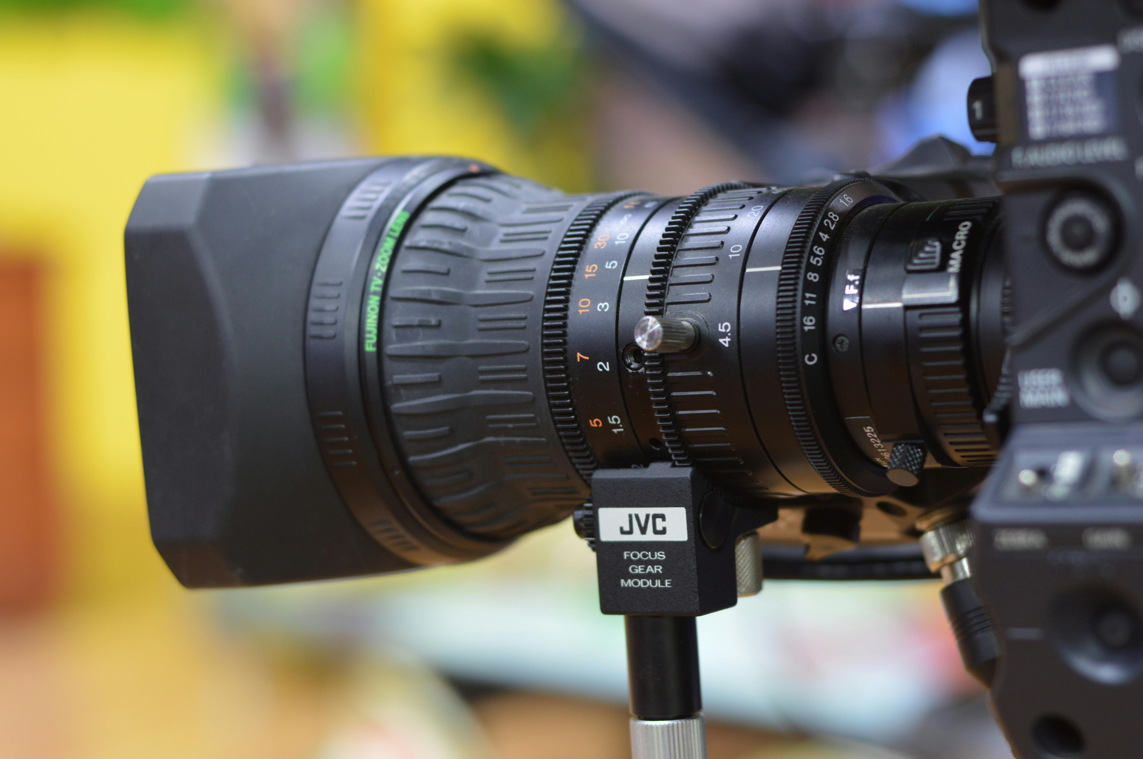

IMPORTANT NOTICE – PLEASE READ

[FED NAME] will be taking photos and/or filming at today’s event.

The images will be kept in a photographic Library for use by [FED Name] Communications Team in any of the following ways:

[FED Name]’s printed publicity, e.g. brochures and information leaflets.

[FED Name]’s online publicity (including Facebook, Twitter, LinkedIn, Instagram or any other social media platform.

To accompany media releases to local news outlets such as (local newspapers name) and their online (worldwide available websites).

